Holy Trials, Holy Fruit, Stand in the Gap for America
October 13, 2016
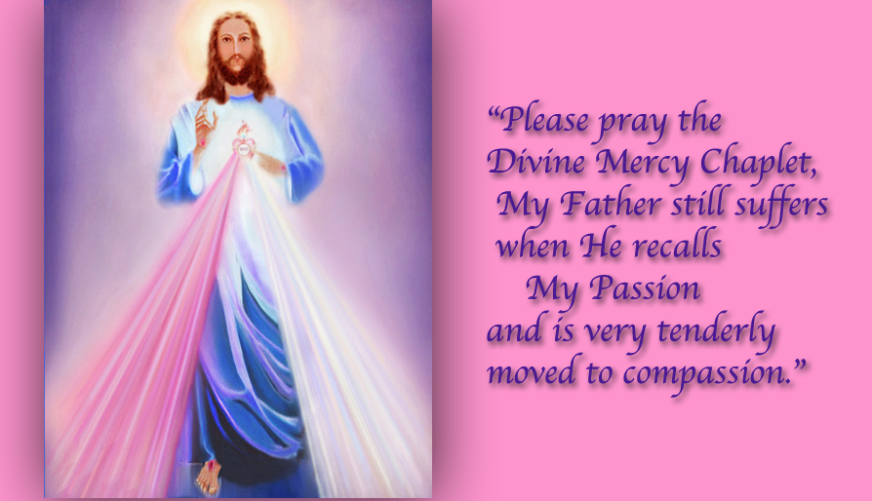
May the faithfulness of the Lord Jesus be our comfort and help.

Well, my precious Heartdwellers…we certainly are on this journey together and I don't for one moment want to withhold my trials from you, because I know they are not unique to me but the entire Body of Christ is going through it right now.
And I want to share His mercy with you.

As I have mentioned before, the Lord Jesus is revealing those dark things in me that cannot enter Heaven and hinder His working through me. I, for my part, am like a little child clinging to her daddy in the midst of a dark mud storm. Where, rather than hail or rain, mud is churning all around me - the mud of my unresolved sinful nature, and the wilderness of my unconquered sinful nature. And not only is it dirty to look at, it reeks to high heaven.

If you are going through intense trials right now, you are right on target and in the boat with those who have said "yes" and want to keep going with the Lord. With my mouth I said yes, but I am seeing skid marks and places where I fell out of the boat and the sharks got a bite of me. They are on a feeding frenzy with the Body of Christ right now, as the Lord allows assists us in fighting our way through our flesh into the pristine purity of the Kingdom of God.

Someone told me there was chatter on the internet about the category 5 hurricane Matthew making landfall on the 10th month and in the 7th day, mirroring Matthew 10:7 As you go, proclaim this message: ‘The Kingdom of Heaven is upon you.’ And for us who are undergoing the purification necessary to continue climbing the mountain of holiness with the Lord, it certainly bears witness to our present trials.

But I have always believed that our trials contain two components: graces released for sufferings endured, as in Simon’s Cross, and God’s correction for things that should not be a part of our nature, and must be removed. We have been assailed by many supernatural attacks, which are bringing us closer and closer to the Holy Mountain. Even though they are painful, the fruit is amazing.

For one, right now the Lord is calling for fast offerings to turn the evil plans of the powers-that-be in this country, to prevent the elections and cause martial law in America. He has told me that many, many attempts would be made to stop them from happening, but that if we continued to pray, fast and offer Him our sufferings - whether they be financial or physical or family related - any suffering we are undergoing can be offered to stop this evil government from getting control for the next four years.

Anything, anything, anything. If it hurts, offer it.

And so while we are being purified, supernatural levers of grace are being raised to prevent catastrophe, and the death knell for America. Oh, the divine economy of Heaven is totally amazing and efficient down to the very last tear. So, take heart; these sufferings are going to bring forth a harvest of righteousness as well as a purification of our hearts.

Truly, all Ezekiel and I have been able to do for the last week, is repent for what the Lord is revealing in our natures. Just when I feel I cannot take another drop, not another look at myself, our Sweet Jesus comes and holds my face tenderly in His hands, “I forgive you. Let’s move on.”

And just when I feel at my most pitiable and weakest, like a smelly and dirty little child pulled out of a hole in the ground, with a runny nose, tangled hair, when I feel at my absolute lowest, He comes and says, “Trust Me.”

I look around and catch a glimpse of myself in His mirror and I don’t understand why my whole world hasn’t fallen apart. The answer is so simple, “unless the Lord guard’s the house, those who guard it do so in vain.” This is His work, from His hands, from His grace and He is the one maintaining - it whether I’m up for it or not! And I guarantee you; I am not up for it!

Guys, this is not a pity party, this is an encouragement to you. Hang in there; God is with you. Don’t fall into despair, don’t run away, don’t give up, don’t give in to dark thoughts Satan is pelting you with. Stand your ground. You are on the Rock and your house is not going to fall, because it is built on the right foundation and His angels have been sent to protect it.

At one point, when my emotions got the better part of me, instead of persevering in prayer I started to go back to my old pattern…nesting. Straightening the house. In the middle of it, I was moved to pick up a Bible and get a word from the Lord…it was all about how Saul disobeyed and offered the incense because Samuel was late and his soldiers were deserting him. Because of that he lost his kingdom. Oh that was a sobering reading, not exactly a sweet hug and encouragement at that moment! I couldn’t wait to get back to prayer and repentance, and the Lord was right there holding my face in His hands again and hugging me to His heart. I saw myself as a little 5-year-old girl clinging to Him for dear life and burying my head in His heart.

The readings from the Missal that I was following for the day's communion service were: Acts 3: Reform your lives! Turn to God, that your sins may be wiped away.”

and

The 1st Letter of John chapter 2:1-6 My dear children, I write this to you so that you will not sin. But if anybody does sin, we have an advocate with the Father—Jesus Christ, the Righteous One. He is the atoning sacrifice for our sins, and not only for ours but also for the sins of the whole world. We know that we have come to know him if we keep his commands. Whoever says, “I know him,” but does not do what he commands is a liar, and the truth is not in that person.
But if anyone obeys his word, love for God is truly made complete in them. This is how we know we are in him: Whoever claims to live in him must live as Jesus did.

Wow - that was just so, so right on!

And the Gospel of Luke 24:46-47 “The Messiah will suffer and rise from the dead on the third day, and repentance for the forgiveness of sins will be preached in his name to all nations…”

So, there was no getting around it, this was about sin and repentance. And the Lord confirmed it in my communion service.

One thing I want to share with you, that I have seen over and over again, when we have a victory in ministry. Immediately after that, we are most vulnerable to a fall. I think that's called "overconfidence." I consider the painting a victory, though it's not quite done yet - so I am not at all surprised at all the trials, especially knowing the elections are close at hand.

At this point, guys, I ran out of what I wanted to share with you, so I asked the Lord: is there anything You want to add?

He began, "My people, if only you knew the battle you are embroiled in now, if only you knew. I am not going to discuss with you what is being planned, but I will tell you this. Whatever you are now suffering is nothing in comparison to what you could be suffering if We do not put a stop to this.

"You recall how I turned missiles around and saved an entire neighborhood from certain death in Jerusalem. Well that was only the beginning. There is so much more I am going to do because of your faithfulness. What is planned is horrendous. What the Father will not allow expands each day you offer Me the littlest of sacrifices. That means in food or convenience, anything, anything that causes discomfort or extra work, delays, suffering and loss, anything counts to stop what evil people are planning for this nation and the world.

"So far, there have been many miracles, many. One was the turnout for the supposed rioting at the Republican convention. There have been so many more. You don’t know about them because they are hidden from you, but rest assured they have been averted by your sacrifices and cooperation with Me.

"As you get closer to the election, things will be more trying and difficult. Please do not walk away in My hour of need. Please stand by Me and allow whatever I allow, giving full consent in the knowledge that your decision is turning the tide in this world. Stand with Me against the evil, stand and do not be fooled by propaganda in the media.

"Do what you know is right and avoid contact with the media. It is a reprehensible sewer spilling effluent all over this nation. If you are close to Me, you will know what is right. If you are not, you will act foolishly, not understanding what is truly at stake in this election.

"I have prepared you for this time. I have prepared you to understand, to sacrifice, to repent and to stand your ground for what is right in this country, and ultimately for the world.

"Please do not neglect the Divine Mercy Chaplet. Coupled with your offerings, it is moving mountains. I offered Myself for you, for your nation and the world. This prayer recalls all that suffering to My Father, Who suffers still from the vision of it. His heart is ever so tender to this prayer. Please use it.

"And remember My face, My eyes, My smile for you, how much I love you and I will not allow you to suffer beyond what you can endure. Recall My face in this portrait, and know that My Heart is Yours and I am still in control.

"Trust."

And I had to look something up in the middle of this message. And the rhema that came up when I logged onto the Internet was: "Offer sacrifice in the right spirit, and trust in the Lord." Holy Spirit uses those rhemas to really drive a point across. And He'll do the very same thing with your Bible readings and your music, if you put it on shuffle and give Him the chance.

